**位置图**

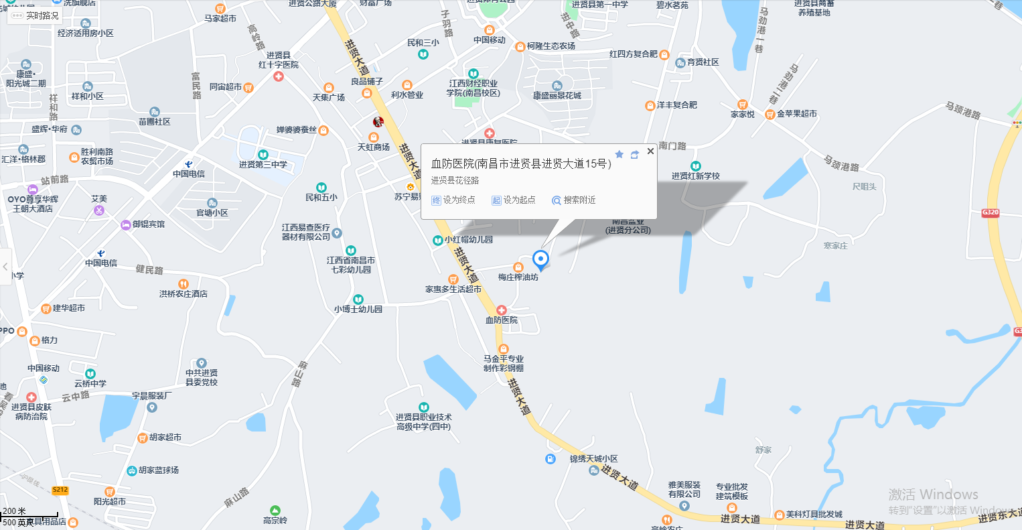

**估价对象**

**现场照片**

|  |  |
| --- | --- |
|  |  |
|  |  |
|  |  |
|  |  |