**估价对象位置图**

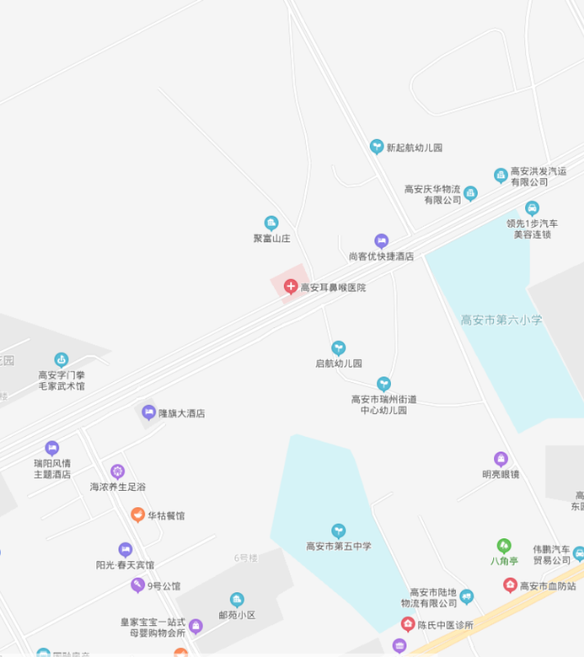

估价对象

**估价对象现状照片**

|  |  |  |
| --- | --- | --- |
| **IMG_20200904_094118** | **IMG_20200904_094023** | **IMG_20200904_093655** |
| **临路状况** | **小区入口** | **楼外观** |
| **IMG_20200909_095848** | **IMG_20200909_095009** | **IMG_20200909_095024** |
| **车库** | **1层内景** | **1层内景** |
| **IMG_20200909_095038** | **IMG_20200909_095041** | **IMG_20200909_095119** |
| **1层内景** | **1层内景** | **1层内景** |
| **IMG_20200909_095543** | **IMG_20200909_095133** | **IMG_20200909_095140** |
| **1层至2层楼梯** | **2层内景** | **2层内景** |
| **IMG_20200909_095149** | **IMG_20200909_095230** | **IMG_20200909_095158** |
| **2层内景** | **2层内景** | **2层内景** |
| **IMG_20200909_095218** | **IMG_20200909_095607** | **IMG_20200909_095306** |
| **2层内景** | **2层至3层楼梯** | **3层内景** |
| **IMG_20200909_095311** | **IMG_20200909_095317** | **IMG_20200909_095326** |
| **3层内景** | **3层内景** | **3层内景** |
| **IMG_20200909_095343** | **IMG_20200909_095631** | **IMG_20200909_095428** |
| **3层内景** | **3层至4层楼梯** | **4层内景** |
| **IMG_20200909_095512** | **IMG_20200909_095508** | **IMG_20200909_095450** |
| **4层内景** | **4层内景** | **楼顶** |