**估价对象位置图**

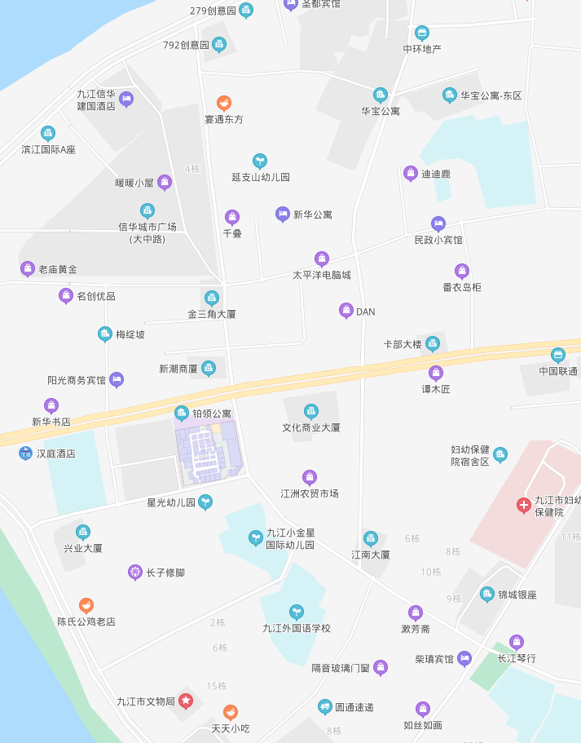

估价对象

**估价对象现状照片**

|  |  |  |
| --- | --- | --- |
| **IMG_20200814_115733** | **IMG_20200814_115804** | **IMG_20200814_115723** |
| **临路状况** | **楼外观** | **物业入口** |
| **IMG_20200814_114815** | **IMG_20200814_113931** | **IMG_20200814_113935** |
| **1311室入户门** | **1311室客厅** | **1311室餐厅** |
| **IMG_20200814_114006** | **IMG_20200814_114022** | **IMG_20200814_114039** |
| **1311室卧室** | **1311室卧室** | **1311室卧室卫生间** |
| **IMG_20200814_113925** | **IMG_20200814_114141** | **IMG_20200814_114111** |
| **1311室厨房** | **1311室阳台** | **1311室公共卫生间** |
| **IMG_20200814_114658** | **IMG_20200814_115012** | **IMG_20200814_115021** |
| **1309B入户门** | **1309B内景** | **1309B内景** |